KIT519 - Software Engineering & HCI

Assessment #1

SDLC and Requirements Engineering

Student Name
Prince Patel - 681355
Ravikumar Savani - 685167
Parth Patel – 684138

Table of Contents
1. Introduction 4
2. Analysis of the Requirement Specification 4
2.1. Overview of the Specification Document 4
2.2. Key Project Requirements and Constraints 5
3. Proposed SDLC Methodology 6
3.1. Identification and Justification 6
3.1.1. Justification for Agile: 6
3.1.2. Project Requirements and Constraints in the Context of Agile: 7
3.2. Phases of the Chosen SDLC 7
3.2.1. Phase 1: Planning 8
3.2.2. Phase 2: Design 9
3.2.3. Phase 3: Implementation 10
3.2.4. Phase 4: Testing 11
3.2.5. Phase 5: Deployment 11
3.2.6. Phase 6: Maintenance 12
4. Critique and Comparison 13
4.1. Agile vs. Waterfall 13
4.1.1. Comparison and Analysis: 13
4.1.2. Conclusion: 14
4.2. Agile vs. V-Model 14
4.2.1. Comparison and Analysis: 14
4.2.2. Conclusion: 15
4.3. Agile vs. Spiral Model 15
4.3.1. Comparison and Analysis: 15
4.4. Final Selection Justification 16
4.5. Rationale for Selection 16
5. Requirements Traceability Matrix (RTM) 18
5.1. Introduction to RTM 18
5.2. Combined RTM 19
6. Conclusion 21
References 22

Table of Figures
Figure 1 Phases of SDLC 8
Figure 2 High-Level System Architecture Diagram 9
Figure 3 Agile Development Process 16
Figure 4 Feedback Loop and Iteration Flow 17
Figure 5 Requirements Traceability Matrix (RTM) Flowchart 18

Introduction
The University of Tasmania has been initiated into the Smart Bin System for managing its waste on campus. The state-of-the-art project will help in increasing the efficiency of rubbish disposal and recycling activities by using sensing and camera technologies in order to detect contamination and monitor fill levels in real time. Since the project is complex and requires changes in requirements during the execution of the project, an appropriate Software Development Life Cycle (SDLC) methodology has to be chosen while implementing the project.
The following report carries through with an intensive study and final recommendation of the most suited SDLC methodology for the Smart Bin System project. It begins with a detailed analysis of the requirement specification of the project, identifying the major requirements and constraints of the project. Then Agile SDLC is suggested as the right methodology and substantiated with an elaborative outline of phases and deliverables of this model. The paper also contrasts Agile with other major SDLC methodologies: Waterfall, V-Model, and Spiral, to justify the selection.
Further, the paper represents a Requirement Traceability Matrix (RTM), mapping project requirements to corresponding deliverables; this ensures traceability right across the process of development. Justification for the choice of Agile is further strengthened by explaining how it can manage risks pertaining to the project and how it is a good fit for the sustainability aims of the university.

Analysis of the Requirement Specification
The project on a Smart Bin System at the University of Tasmania is a project aimed at modernizing the current waste management practice at the University with high-end technologies such as sensors and cameras for the fill levels of the bins and contamination. With the university's drive toward sustainability, the project will seek out new methods for managing waste efficiently with minimized environmental impact.

Overview of the Specification Document
the main hardware and software components used in the Smart Bin System will come out. The hardware involves the sensors and cameras integrated within the existing bin infrastructure, designed to pick up waste contamination and levels of filling without interfering with one's privacy. The software element concerns the monitoring system that provides real-time data to the infrastructural team in view of proper decision-making for both waste collection and its management in relation to contamination. This is in addition to the specification, which notes how privacy and data security will be achieved in such a way that the system will not capture information that identifies people. This relates well with modern data protection principles that have been very paramount in the design of systems where potentially sensitive information could be collected (Cavoukian, 2009). There is also a project scope for user feedback and reporting, analytics, and an enormous maintenance scheduling system.

Key Project Requirements and Constraints
Most fundamental for the Smart Bin System is the need to improve efficiency in waste management on the university's campus. It makes sure that technology is installed which will automatically sense contamination or whether bins are full, thus doing away with manual checks (Kofoworola and Gheewala, 2008). The system should alert the infrastructure team in real time; otherwise, small issues could turn into bigger challenges, such as overflowing wastes or material contamination, considering that recyclable materials are mixed at source.
The solution has a key project constraint: it needs to be user-friendly and safe. The system should focus on maintaining data privacy—no identifiable information should be captured, and data sent to the monitoring system must be encrypted. This also meets the current requirements with respect to data security for the IoT system, which needs to have strong encryption and access controls for user data (Roman et al., 2013). Besides, the system must be scalable as university waste management infrastructure expands in the future. This involves giving the software the ability to cater for more increased data loads by incrementing the number of bins each time and also ensuring that the hardware is stable enough to support normal usage in varying environmental conditions. Realisation of this project will, therefore, be based on taking into consideration the requirements and constraints of the Smart Bin System well in perspective with the need to achieve effectiveness and sustainability of the system over the long term.

Proposed SDLC Methodology

Identification and Justification
Agile SDLC is identified as the appropriate methodology for the Smart Bin System project at the University of Tasmania. Agile is quite adaptive, iterating on process and development with flexibility, collaboration, and feedback from customers, hence proper for complex, developing projects such as the Smart Bin System.
Agile Methodology Overview: Agile development is when a project is broken down into small, manageable increments called sprints. Each increment usually takes two to four weeks. A potentially shippable product increment is delivered at the end of each sprint, keeping the evaluation and iteration by feedback continuous (Kuhrmann et al., 2021). The approach can be much more useful with projects where requirements are supposed to change, possibly after the delivery of a product.

Justification for Agile:
- Flexibility in Evolving Requirements: The development of the Smart Bin System is basically the embedding of new technological systems, for instance, sensors and cameras, to the already existing system. This is an innovative project, and as such, chances are that there are bound to be changes in the requirements during the development. The iterative nature of Agile allows development teams to become flexible in accommodating changing requirements and continuously integrating feedback from stakeholders with the view of ensuring the system is in close conformance with university needs and goals for sustainability (Al-Saqqa et al., 2020).
- Continuous Stakeholder Collaboration: Agile requires periodic interactions between the development team and stakeholders, which becomes very important in the Smart Bin System project. Key stakeholders who will need to input or be consulted throughout the course of the project include the university's infrastructure and sustainability teams, as well as local council authorities (Abdullah et al., 2024). The framework for Agile ensures that continuous reviews and feedback sessions are done so that the project remains on course according to the expectations of the stakeholders, and any arising issues dealt with at the right time.
- Risk Mitigation: Agile stresses on iteration of development and testing, which effectively mitigates risk during the early identification. In this context, for a project such as the Smart Bin System, where hardware and software components need to be integrated, there is an ability to test and refine individual components during each sprint, thereby reducing the risk of system-wide failures. This is very important, especially in this project, since it involves the issue of privacy and data security.
- User-Centric Design: Agile is a user-centric methodology and based on the feedback; it is imperative to make certain that the Smart Bin System is designed and developed with interest not just on paper but practically so, for the infrastructure team and staff on campus. By developing the system incrementally through the iterative process of development and in response to feedback from users, it enables the development team to ensure it will be not only a functional system in the end but also in a real-world context (Hema et al., 2020).

Project Requirements and Constraints in the Context of Agile:
The Smart Bin System project has many key requirements that includes as real-time monitoring of bin fill levels, waste contamination detection, as well as strong privacy control. An Agile iterative process can allow the requirements to be developed incrementally, with each sprint focused on a specific set of features. One of the key limitations of the project is that it is important that all collected data should be safe, secured, and no identity information should be documented. The iterative testing process of Agile lets the development team focus on these security elements throughout the development life cycle, as opposed to just the final stage. It helps ensure that the system complies with privacy standards from the outset (Kuhrmann et al., 2021). It is based on the integration of the system with the existing infrastructure in the university. There is flexibility in Agile, and this allows for fine-tuning and adjustments to fit into the prevailing systems, hence making risks associated with the problems of integration lesser during deployment.

Phases of the Chosen SDLC
The Smart Bin System project at the University of Tasmania adopts the Agile SDLC and encompasses six key phases: Planning, Design, Implementation, Testing, Deployment, and Maintenance. Each of the phases will be important in ensuring that the system is developed and deployed successfully, with its own specific goals and deliverables to guide the project through its life cycle.
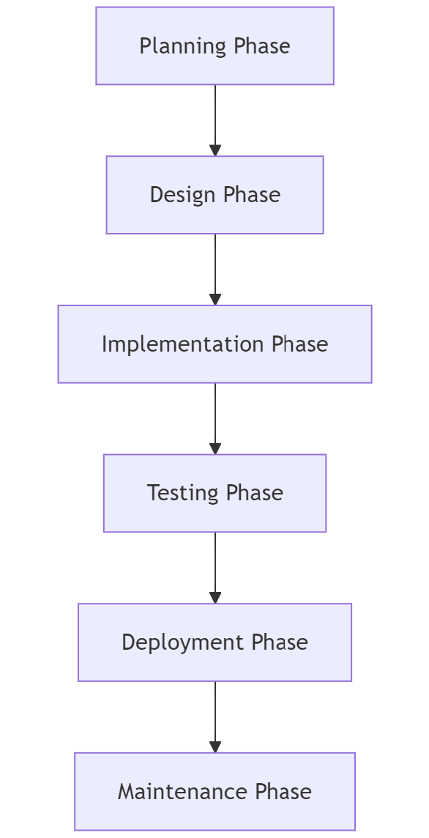
Figure 1 Phases of SDLC

Phase 1: Planning
Goals:
The Planning Phase is very crucial, as it lays down the ground base of the project. The main objectives that are achieved in this phase include detailed requirements gathering, defining the project scope, and feasibility analysis. The close working with key stakeholders within the university—that is, the sustainability and infrastructure management teams—helps in determining needs and expectations from the smart bin system. The resources, budget, and time to complete the project are also identified in this phase.
Deliverables:
- Project Plan: The project plan is an exhaustive document that describes the project in terms of its objectives, timelines, resources, and milestones. This would, in fact, be a roadmap for the entire development process and would give an idea quite lucidly about what is to be done and when it is to be accomplished.
- Feasibility Report: The feasibility report determines the technical, financial, and operational viability of the project. This goes a long way in ascertaining the viability of the project and worthiness of pursuing it, since the analysis of available resources and possible risks to be incurred in terms of outcomes expected can be projected (Kerzner, 2022).
- Requirement Specification: This is the document that specifies the various functional and non-functional requirements of the Smart Bin System, such as real-time monitoring, contamination detection, and privacy controls. The requirement specification is very important for ensuring that all the project stakeholders get a common understanding of what the system is going to deliver (Wiegers & Beatty, 2013).

Phase 2: Design
Goals:
The phase of Design takes a transformation approach, turning requirements into the blueprint of the system. The goals include developing the system architecture and the design of the user interface and user experience. This stage ensures that all technical issues are put down, from how the various components will relate to each other to how the users will interact with the system.
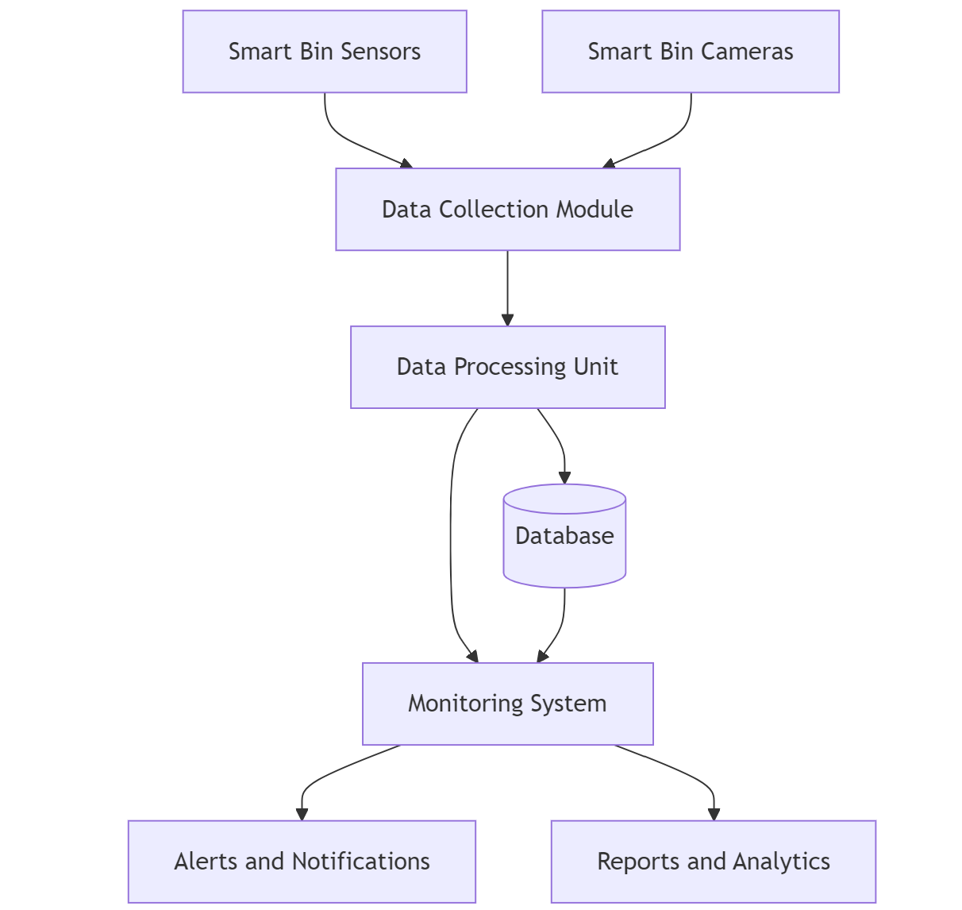
Figure 2 High-Level System Architecture Diagram
Deliverables:
- System Design Documents: These are documents that provide in-depth design details of the system, like both hardware and software components, the path of data flow, and system integration points. The design should cater to the sensors, cameras, and the monitoring system so that the working of the same can be in order (Bass, 2012).
- UI/UX Prototypes: The UI/UX prototypes are the visualization of the interface of the system, which will help the stakeholders see the same to give their review and feedback on how the system will appear and feel like once it is implemented. Through the given prototypes, the system is user-friendly and thus, meets the expectation of the users (Ceccacci et al., 2022).

Phase 3: Implementation
Goals:
The implementation phase is the one that actually designs the Smart Bin System. Two major goals are covered in the coding and module development sections, which are the conversion of the design into a system that is able to function and the actual writing of source code by developers, where each piece of hardware is integrated with the software, along with ensuring that every single module functions correctly.
Deliverables:
- Source Code: Source code is a core output of the implementation phase and represents the functionality of the system. It contains the source code for sensors, cameras, and the monitoring system written in languages such as Python and JavaScript.
- Test Cases: In parallel to coding, test cases are developed so that each module performs the functionality it was actually intended to. The test cases shall be used in the subsequent Testing phase to validate the performance of the system (Kuhrmann et al., 2021).

Phase 4: Testing
Goals:
The Testing phase ensures quality and reliability for the Smart Bin System. The goals of this phase also include validation of the system against the requirements, verification that all components work as a whole, and pinpointing debugging against defects. Testing assures meeting all functional and non-functional requirements by the system before deployment.
Deliverables:
- Test Plan: The test plan is a document that captures the strategy, scope, and objectives that drive the testing exercise. Such a document outlines the test environment, method of tests to be utilized, pass criteria for every test, among others (Santos et al., 2022).
- Test Reports: Results of the testing process that show detected defects and how severe they are, with steps on how they can be resolved. Therefore, the test reports are a clear record of the quality and readiness of the system for deployment.
- Defect Logs: These logs track the detected bugs or issues during the tests by providing the statuses and how they are resolved. This log ensures that every problem is resolved before the system becomes live (Miranskyy et al., 2021).

Phase 5: Deployment
Goals:
The Deployment phase involves the actual implementation of the Smart Bin System within the university infrastructure and ensuring that it functions properly in a live environment. This phase also involves training users on how to interface with the system and documentation for the use and maintenance of the bins.
Deliverables:
- Deployment Guide: Provides a comprehensive guide on how this system can be established and step-wise configured in the live environment—sensor setup, camera setup, the monitoring system, and possible integration steps with the already present infrastructure (Fahmideh et al., 2021).
- User Manuals: These are developed for the guidance of campus staff and the infrastructure team in operating the system. These manuals detail all the system functions and features; for example, how to inquire about bin levels or how to print a report.
- Training Materials: Training materials may be provided in learning so that users will fully grasp the proper operation of the system. This could be done with video tutorials, quick reference guides, or actual training in a classroom-type setting.

Phase 6: Maintenance
Goals:
The Maintenance phase is ongoing and involves all forms of support required to ensure the Smart Bin System continues working after deployment. The aim is to address any arising issues, update the system, and maintain it to meet university needs.
Deliverables:
- Maintenance Logs: The maintenance logs include all support activities going on, repairs, updates, and user support request logs. These logs are very important in keeping the system in top shape, and any fault that is impending, therefore, can be corrected in time (Laplante and Kassab, 2022).
- System Updates: For due improvement over time, because of technological advancement and change of needs of the university, there can be a necessity for updates on the system to provide the Smart Bin System with more enhanced functionalities. An update is needed to ready the system for better long-term relevance and better performance.

Critique and Comparison
When selecting the most appropriate Software Development Life Cycle (SDLC) for the Smart Bin System project at the University of Tasmania, there is a critical need to consider the chosen Agile methodology in comparison to other well-considered SDLC models such as Waterfall and V-Model. A comparison between these will show their pros and cons; therefore, a justification based on these merits will be accorded on why Agile will be considered for this project.

Agile vs. Waterfall
Agile Methodology: Agile is an iterative and incremental approach emphasizing flexibility, collaboration with customers, and rapid delivery of their needs. It would be particularly useful for projects where changes are expected or the requirements are not understandable at the initial stage of a project (Kuhrmann et al., 2021). Since it is very adaptive, Agile makes it easy for refinement at each step, according to the needs of stakeholders. Thus, it has a great fit in innovative projects like the Smart Bin System, where technology may change its integration or user needs may change during project development.
Waterfall Methodology: Waterfall follows a linear and sequential model; it is a very strict phase-by-phase manner, and one cannot proceed to the next phase without completing the previous. It is most applicable to projects with rigidly defined requirements and minimum expected changes over the lifetime of a project (Hossain, 2023). Due to the deterministic nature of Waterfall, it ensures maximum documentation and sharp milestones of benefit; thus, it is most beneficial in instances where the project has to meet certain regulatory requirements or under some confined scope.

Comparison and Analysis:
- Flexibility: Agile is much more flexible than Waterfall. On the flip side, due to Waterfall's inflexible framework, it becomes very hard to adapt the changes when the project has already been executed after the planning and requirement phase. Due to the innovative nature and possibility of a dynamic change in the requirements for this Smart Bin System, flexibility coming from Agile is highly advantageous.
- Stakeholder Involvement: Unlike Agile, which keeps the stakeholders involved throughout the incremental development cycles and ensures that a product developed will meet the users' expectations, Waterfall is highly concerned with stakeholder engagement during the planning phase. These may not be practical, hence mismatch of the resultant product with the users' expectations in case of a requirement change.
- Risk Management: Agile's iterative testing and development support the identification and dealing with risks at an early stage; therefore, it is more appropriate to be used for projects which have either uncertain or evolving requirements. On the other hand, the more sequential approach of design, development, and only then testing and validation in the Waterfall model may expose the project to more serious risks, as during the testing and validation stage, there is no earlier testing done, but it is carried out after the whole system is developed.

Conclusion:
Although Waterfall is structured in a way that makes it help in getting clear documentation and milestones, its rigidness does not make it fit for the Smart Bin System project. The reason is that changes are expected in requirements; thus, frequent feedback from stakeholders becomes something of prime importance. Agile wins here due to adaptability, stakeholder collaboration, and managing risks iteratively.

Agile vs. V-Model
Agile Methodology: Agile methodology is quite adaptive with its iterative development cycles based on flexibility and, majorly, focused on continuous improvement and feedback. It helps in rapid adjustment depending on the real-time feedback; thus, it's suitable for the kind of project that has dynamic or rather unclear requirements from the beginning of a project (Al-Saqqa et al., 2020).
V-Model Methodology: The V-model, like the Waterfall model, puts a maximum emphasis on verification and validation within each development phase. The model is highly oriented toward high structuring, ensuring that each development phase is accompanied by a corresponding testing phase (Gurung et al., 2020). The V-Model is best for safety-critical systems in which the level of validation and verification has to be at the best level.

Comparison and Analysis:
- Validation and Verification: The V-Model permits parallel development phases, and testing is embedded in every phase, offering maximum validation for all the aspects of the project—an influential factor, most concerned with projects of a sensitive nature for quality and compliance. However, it can at the same time be a little bit over-restrictive for the Smart Bin System because of the reason that the requirements are likely to change with the feedback of users and improvements in technology.
- Adaptability: Although the V-Model performs excellently in an environment where the requirements are stable throughout the entire project life cycle, its rigidity makes it very hard for change once development has started. Agile, by its nature, is adaptable and keeps the project on its toes to switch to a new orientation at any point in time with new information or stakeholders' feedback during the development process.
- Speed of Delivery: Agile, with its iterative sprints, can be very fast in delivering functional components to the customers or stakeholders for repeated and early visibility within the project cycle. The V-Model approach in its sequential testing process may have longer lead times before a working product is seen by stakeholders. This could then be a disadvantage in a project like the Smart Bin System, which would require these quick iterations and feedback loops.

Conclusion:
The V-Model is meant to be very strict in verification and validation but is inappropriate for a project as uncertain and unpredictable as the Smart Bin System.

Agile vs. Spiral Model
Agile Methodology: Agile's strengths are in its flexibility, an iterative approach concentrating on regular collaboration with stakeholders. Such characteristics make it most appropriate for projects with changing requirements and which require quick incremental developments (Hema et al., 2020).
Spiral Model: The Spiral Model is an approach driven by risks that incorporates both iterations and the Waterfall methodologies. It brings to light risk assessment and mitigation between the commencement and end of a development cycle; hence, it is very beneficial for complex and significant projects with a high-risk factor (Gurung et al., 2020).

Comparison and Analysis:
- Risk Management: The Spiral Model's method of risk assessment and prototyping through iterative loops comes to great help in highly risky projects. However, the amount of risk management in this model may seem an overkill for the Smart Bin System, as the integration in this project is not a matter of high-stake risk management but linking old infrastructures with new technologies.
- Complexity: The Spiral Model may be difficult to administer. There is a tremendous amount of overhead involved in managing the various types of risk assessments and the number of iterations. Agile is better suited to this project: The Smart Bin System implementation is simple and focused on fast delivery of the functional component.
- Stakeholder Engagement: Agile follows continuous stakeholder engagement. It makes sure that through all different stages of the project, it will be on track according to the needs of users. On the other hand, the Spiral Model focuses on risk management, thus sometimes distracts many from quick, user-driven development. The complexity and overhead that it introduces are not merited for use in the Smart Bin System project. Agile, with its blend of flexibility, speed, and stakeholder involvement, is, therefore, the most appropriate approach with this project where interest would be lying in the iterative development of the Smart Bin System with improvements driven by users.

Final Selection Justification
After a critical comparison of Agile with the Waterfall, V-Model, and Spiral, it is evident that Agile is the most appropriate SDLC to be used for the Smart Bin System project. Agile is flexible, iterative, and has an element of stakeholder collaboration, all of which should best fit the project needs. The possible evolution of requirements, the need for quick feedback loops, and the importance of user-centric design make Agile the best fit. The Smart Bin System development team will adopt Agile to make sure that the system developed for the university is functional while being responsive to the dynamic needs and sustainability goals of their community

Rationale for Selection
Agile SDLC was chosen as the process to follow in this Smart Bin System project, since it is flexible and iterative with good collaborator stakeholder involvement. It adjusts perfectly to changed requirements with this innovative and evolving project, which is critical for Agile. The integration of state-of-the-art devices, including sensors and cameras, would need to be realized in existing infrastructures that must be modified to reflect new insights and challenges developed during the process (Al-Saqqa et al., 2020). This makes it feasible for the team to deliver a fully functional increment in a very short cycle with Agile's iterative nature, thus allowing continuous feedback by stakeholders to ensure that the project is aligned with the needs and expectations of the users.
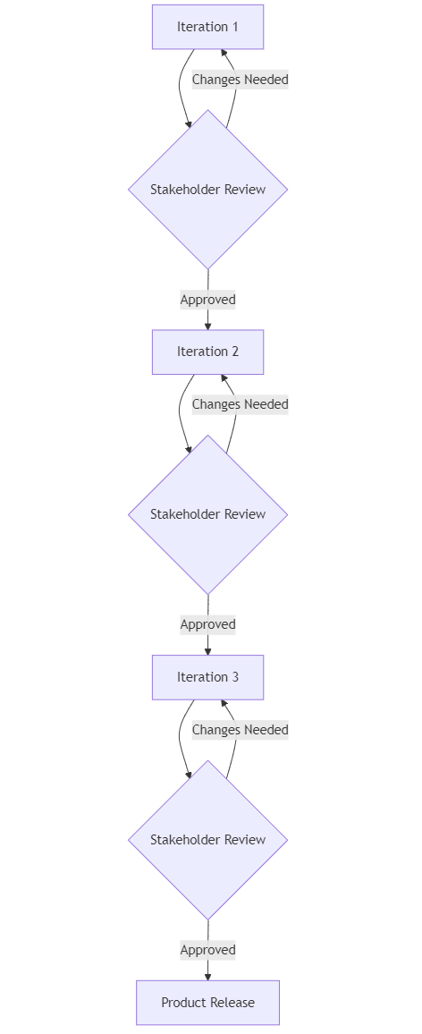
Figure 3 Agile Development Process
Besides, the exercise of early testing and very frequent testing can reduce the chance of any major occurring to the system at a later stage of the development process. In Agile, continuous validation of the system functions and feedback at every point within a project could help in the detection of any potential risks early and also help to mitigate them (Hema et al., 2020). In this case, it particularly benefits the Smart Bin System by ensuring that the hardware is integrated with the software part, which may otherwise face certain incompatibilities. Iterative testing and development done at Agile enable early detection of potential issues and ensure they are fixed in time for smooth deployment.
Additionally, Agile helps to control the risks of scope creep through controlled sprints and regular re-prioritization of tasks. In this respect, Kuhrmann et al. (2021) noted that Agile further reduces the risks of delays and cost overruns, which are possible at each stage due to its flexibility in requirements changes without affecting the timeline of the project. Therefore, the Smart Bin System project should apply Agile, with the adaptability, risk handling, and stakeholder engagement needed toward a successful delivery of this innovative solution.
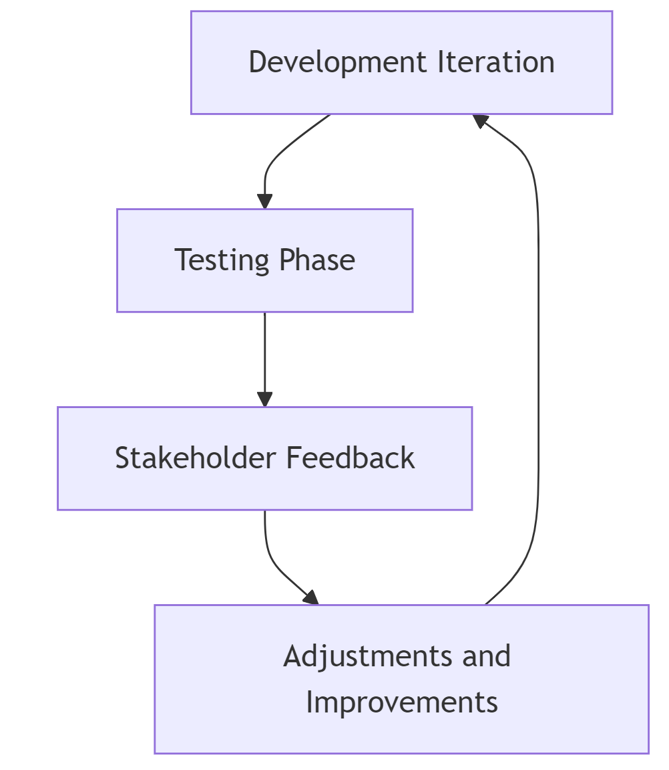
Figure 4 Feedback Loop and Iteration Flow

Requirements Traceability Matrix (RTM)

Introduction to RTM
An RTM is one of the most critical tools in project management and software engineering through which all requirements of a project are tracked through the development lifecycle. RTM gives a detailed linkage of every requirement with its corresponding deliverables and, hence, assures that each and every aspect of the project is covered and nothing has been let out. Since RTM is in place, any discrepancies or gaps are identified early on in the developmental process from requirements gathering to testing and deployment (Laplante and Kassab, 2022).
The importance of an RTM is realized because it helps to ensure the final product attains the initial requirements put in place and the expectations of the stakeholders. It enables the effective communication of teams working on a project, efficient change management, and also acts as a basis for performing validation and verification. Properly defined, an RTM is important in ensuring regulatory compliance and quality assurance, especially where standards are necessary for industrial and process operations. On the whole, RTM is a must-have with regard to being in a position to keep control of complex projects and to make sure that all requirements are fulfilled successfully.
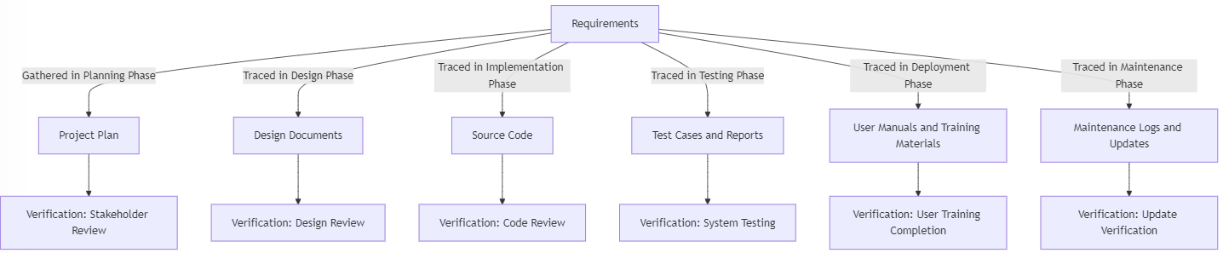
Figure 5 Requirements Traceability Matrix (RTM) Flowchart

Combined RTM
This combined RTM integrates the contributions from all three members.
Requirement ID | Requirement Description | SDLC Phase | Deliverable | Verification Method
R1 | Gather detailed requirements from stakeholders | Planning | Requirement Specification | Stakeholder Review
R2 | Define project scope and objectives | Planning | Project Scope Document | Project Scope Approval
R3 | Conduct feasibility study | Planning | Feasibility Report | Feasibility Review
R4 | Develop project plan including timeline and resources | Planning | Project Plan | Project Plan Review
R5 | Design system architecture | Design | System Design Documents | Design Review
R6 | Design user interface and experience | Design | UI/UX Prototypes | Usability Testing
R7 | Develop source code for system modules | Implementation | Source Code | Code Review
R8 | Develop test cases for functional validation | Implementation | Test Cases | Test Case Review
R9 | Validate system against requirements | Testing | Test Reports | System Testing
R10 | Verify integration of all system components | Testing | Integration Test Report | Integration Testing
R11 | Install system in live environment | Deployment | Deployment Guide | Installation Verification
R12 | Train users on system operation | Deployment | User Manuals, Training Materials | User Training Completion
R13 | Provide ongoing support and updates | Maintenance | Maintenance Logs | Support Logs Review
R14 | Implement system updates based on user feedback | Maintenance | System Updates | Update Verification

6. Conclusion
The choice of Agile Software Development Life Cycle for the Smart Bin System project at the University of Tasmania was due to the need for flexibility, iterative development, and close stakeholder collaboration. The innovative character of the project, defined by integration with modern technologies into an existing setup, demands a methodology that will adapt to varying requirements and allow continuous feedback. This is why Agile, being focused on delivering functional increments within short cycles, keeps the project always aligned with the needs of its users; moreover, it helps to avoid possible risks since it applies an iterative testing and validation process early in the development stage.
It can be summarized that this was the stage at which we had to now critically analyze the methodologies that had weighed in with their pros and cons during the different stages of this process—Waterfall, V-Model, Spiral, and Agile. However, Agile came out as the most suitable one due to its adaptability, stakeholder engagement, and risk management capabilities—all crucial for successful execution of the Smart Bin System project.
Agile has the best potential to fulfill the objectives of this Smart Bin System, as it is a responsive framework accommodating change and is keen on delivering high quality, user-centric solutions. The project will be realized within its goal to improve waste management practice at the university through the adoption of Agile, hence a sustainable and successful outcome.

References
Al-Saqqa, S., Sawalha, S. and AbdelNabi, H., 2020. Agile software development: Methodologies and trends. International Journal of Interactive Mobile Technologies, 14(11).
Abdullah, Z., Saher, N., Elahi, A.I. and Fareed, S., 2024. Effect of Human Factors in the Success of Agile Software Project: A Quantitative Study. Journal of Computing & Biomedical Informatics.
Bass, L., 2012. Software architecture in practice. Pearson Education India.
Cavoukian, A., 2009. Privacy by design: The 7 foundational principles. Information and privacy commissioner of Ontario, Canada, 5, p.12.
Ceccacci, S., Generosi, A. and Mengoni, M., 2022. A System to Support the Design and Management of Customer Experience Based on a Customer-Centered Approach. In Design Tools and Methods in Industrial Engineering II: Proceedings of the Second International Conference on Design Tools and Methods in Industrial Engineering, ADM 2021, September 9–10, 2021, Rome, Italy (pp. 753-760). Springer International Publishing.
Fahmideh, M., Ahmad, A., Behnaz, A., Grundy, J. and Susilo, W., 2021. Software engineering for internet of things: The practitioners' perspective. IEEE Transactions on Software Engineering, 48(8), pp.2857-2878.
Gurung, G., Shah, R. and Jaiswal, D.P., 2020. Software development life cycle models-A comparative study. International Journal of Scientific Research in Computer Science, Engineering and Information Technology, 6(4), pp.30-37.
Hema, V., Thota, S., Kumar, S.N., Padmaja, C., Krishna, C.B.R. and Mahender, K., 2020, December. Scrum: An effective software development agile tool. In IOP Conference Series: Materials Science and Engineering (Vol. 981, No. 2, p. 022060). IOP Publishing.
Hossain, M.I., 2023. Software Development Life Cycle (SDLC) Methodologies for Information Systems Project Management. International Journal For Multidisciplinary Research, 5(5), pp.1-36.
Kuhrmann, M., Tell, P., Hebig, R., Klünder, J., Münch, J., Linssen, O., Pfahl, D., Felderer, M., Prause, C.R., MacDonell, S.G. and Nakatumba-Nabende, J., 2021. What makes agile software development agile?. IEEE transactions on software engineering, 48(9), pp.3523-3539.
Kofoworola, O.F. and Gheewala, S.H., 2008. Environmental life cycle assessment of a commercial office building in Thailand. The International Journal of Life Cycle Assessment, 13, pp.498-511.
Kerzner, H., 2022. Innovation project management: Methods, case studies, and tools for managing innovation projects. John Wiley & Sons.
Laplante, P.A. and Kassab, M., 2022. Requirements engineering for software and systems. Auerbach Publications.
Miranskyy, A., Zhang, L. and Doliskani, J., 2021. On testing and debugging quantum software. arXiv preprint arXiv:2103.09172.
Roman, R., Zhou, J. and Lopez, J., 2013. On the features and challenges of security and privacy in distributed internet of things. Computer networks, 57(10), pp.2266-2279.
Santos, I., Melo, S.M., Souza, P.S. and Souza, S.R., 2022. A survey on the practices of software testing: a look into Brazilian companies. Journal of Software Engineering Research and Development, 10, pp.11-1.

